System Design
Inventory Management System
Version 1.0 ● 26 June 2015


JC Softwares Integrated Systems

SYSTEM DESIGN

<CLIENT NAME>
INVENTORY MANAGEMENT SYSTEM
Version 1.0

Approver Name | Title | Signature | Date
Ermme Veltran | FAD Manager
Edwin T. Marfil | IT Manager
Dominica Chua | COO

Contents
Section 1. Introduction 1
1.1 Purpose 1
1.2 Scope 1
Section 2. System Architecture 2
2.1 Architectural Design Approach 2
2.2 Architecture Design 2
Section 3. Data Dictionary 2
Section 4. System Domain Design 4
4.1 System Domain Chart 4
4.2 System Domains 4
Section 5. Data Design 4
Section 6. User Interface Design 4
6.1 Log In 5
6.2 MDI 5
6.3 Master Files (Banks) 6
6.4 Master Files Detail (User) 6
6.5 Investments 7
6.6 Investment Detail 7
Section 7. Flow Chart 8
Section 8. Use Case 9
Section 9. Glossary 10
Section 10. Revision History 11

Section 1. Introduction

1.1 Purpose
The system aims to effectively monitor investments, ensure timely recording of interest earned and control bank transactions.

1.2 Scope
The system will allow the Cashier to record all temporary investments which will be subjected for approval by defined signatories. The system has an alert mechanism that will notify the Cashier prior to the temporary investment’s maturity date and will be provided with an option to rollover, terminate, or withdraw investment which is also subject for approval. An email notification will send to the approver and they will just reply their actions. The system will record all the accounting entries on every approved transaction and will send an email notification to the bank containing the details of the bank transactions to be made on the temporary investments on maturity. Journal Entries are created which will also be designed to interface with the oracle system. The system will provide reports that will show these temporary investments by Bank, Terms, and by Maturity Date.

Section 2. System Architecture

2.1 Architectural Design Approach
The system will be using a 2-tier architecture. In this, we need to have a networked client and server machines. Our database will be located in the server and our client will connect and use that database.

2.2 Architecture Design
Database
Server
Client

Section 3. Data Dictionary
P/F | Field Name | Description | Data Type | Field Size
P | GLCode | General Ledger Code | varchar | 30
F | Bank | Bank Name | varchar | 30
 | AccountType | Account Type | varchar | 50
 | PlacementAmount | Principal Amount | decimal | 10,2
 | PlacementDate | Date of Placement | date
 | MaturityDate | Maturity Date | date
 | Tenor | No. of Days | int | 5
 | InterestRate | Interest Rate Percentage | decimal | 5,3
 | InterestEarned | Interest Earned on Maturity | decimal | 10,2
 | WithholdingTax | Tax Percentage | decimal | 5,3
 | TaxAmount | Withholding Tax Amount | decimal | 10,2
 | InterestEarnedNetOfTax | Interest Earned Net of Tax | decimal | 10,2
 | TotalAmountOnMaturity | Maturity Value | decimal | 10,2

Section 4. System Domain Design

4.1 System Domain Chart

Client
Server
Email

4.2 System Domains
The 3 major domains in this system are Client, Server, Email. Data will travel on these 3 domains. They are used for cross monitoring, creating, updating, removing and approving of an existing records.

4.2.1 Client
This application will be used by Cashiers in monitoring maturity and earnings of investments.

4.2.2 Server
This application will be used in storing of data coming from clients.

4.2.3 Email
Server will send email notifications to the approver and approval will reply on their disposition in an matured investments.

Section 5. Data Design
It is the database design of the system and the relationship of its table.
Bank
Investments
Users
Investment Header

Section 6. User Interface Design

6.1 Log In

6.2 MDI

6.3 Master Files (Banks)

6.4 Master Files Detail (User)

6.5 Investments

6.6 Investment Detail

Section 7. Flow Chart

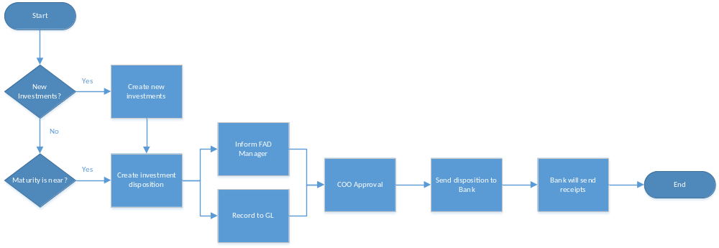

Section 8. Use Case
Masterfile Administration
FAD Manager
Investment Monitoring
GL Recording
Report Generation
Approvals
Cashier

Maturity Disposition
COO
GL Encoder

Section 9. Glossary
Client - It is the application installed on the client laptop of cashier so that it can manage and monitor the investments maturity and earnings.
Server - It is where our database resides.
Investments - It is the money invested in the bank and earns certain amount upon maturity.
Cashier - It is an employee of RAFI that manages and monitor investment maturity and earnings.

Section 10. Revision History
Version | Date | Name | Description
1.0 | 06-26-2015 | Jesryl A. Plarisan | First Release

